Java Swing
Java Swing was introduced as part of the Java Foundation Classes (JFC) in the late 1990s, aiming to address the limitations of the earlier Abstract Window Toolkit (AWT). Unlike AWT, that relies on the native platform's components for rendering, Swing is entirely written in Java, offering a consistent look and feel across different operating systems.
Swing provides a comprehensive set of components for building GUIs, including buttons, text fields, panels, and more. These components are highly customizable, allowing developers to create visually appealing and user-friendly interfaces.

Key Features of Java Swing
Platform Independence: One of the primary advantages of Swing is its platform independence. Applications developed using Swing can run on any platform that supports Java, without requiring modifications.
Rich Set of Components: Swing offers a wide range of components that can be used to create complex GUIs. Developers can choose from basic components like buttons and labels to advanced components such as tables, trees, and scroll panes.
Customizability: Swing components are highly customizable, allowing developers to control various aspects of their appearance and behavior. Properties such as size, color, font, and layout can be easily adjusted to meet specific design requirements.
Event Handling: Swing provides a robust event handling mechanism that allows developers to respond to user interactions, such as button clicks and mouse movements. This enables the creation of interactive and responsive applications.
Layout Managers: Swing includes a set of layout managers that facilitate the arrangement of components within a container. Layout managers automatically adjust the position and size of components based on the container's size, ensuring consistent behavior across different screen resolutions and devices.

Modern Applications of Java Swing
While newer GUI frameworks such as JavaFX and web technologies like React and Angular have gained popularity in recent years, Java Swing remains a viable choice for certain types of applications:
Desktop Applications: Swing is well-suited for developing desktop applications that require a rich and responsive user interface. Applications like IDEs (Integrated Development Environments), productivity tools, and multimedia players can benefit from Swing's extensive feature set.
Legacy Systems: Many enterprise applications built with Swing continue to be in use today. While these applications may not leverage the latest technologies, Swing provides a stable and reliable platform for maintaining and extending existing systems.
Educational Purposes: Swing is often used as a teaching tool in computer science courses to introduce students to GUI programming concepts. Its simplicity and versatility make it an ideal choice for beginners learning Java programming.

Unravelling the Core Features of Java Swing
Platform Independence and Consistency:
Swing liberates developers from platform-specific constraints by providing a pure Java implementation of GUI components. This ensures consistent behavior across different operating systems, enabling developers to target a diverse range of environments without sacrificing user experience.
Extensive Component Library:
Swing boasts a comprehensive suite of components, ranging from foundational elements like buttons and labels to more complex constructs such as tables, trees, and tabbed panes. These components are highly customizable, empowering developers to tailor the appearance and behavior of their applications to meet specific requirements.
Flexible Layout Management:
Swing's layout managers offer a flexible and intuitive way to arrange components within containers, accommodating various screen sizes and resolutions. Developers can choose from a range of layout managers, including BorderLayout, GridLayout, and GroupLayout, to achieve precise control over the arrangement and alignment of GUI elements.
Event-Driven Architecture:
Swing follows an event-driven programming model, where user interactions and system events trigger responses from the application. This architecture facilitates the creation of interactive and responsive user interfaces, allowing developers to seamlessly integrate user input with application logic.
Graphics and Rendering:
Swing provides robust support for graphics and rendering, allowing developers to create custom components, render complex shapes, and implement advanced visual effects. With features like double buffering and hardware acceleration, Swing applications can deliver smooth and visually appealing user experiences.

Advanced Capabilities and Modern Applications
Concurrency and Multithreading:
Swing's concurrency model enables developers to design responsive applications that remain highly performant even under heavy workloads. By leveraging features such as SwingWorker and Event Dispatch Thread (EDT), developers can offload time-consuming tasks to background threads while keeping the user interface responsive and interactive.
Integration with JavaFX and Web Technologies:
While Swing remains a standalone framework, it can be seamlessly integrated with JavaFX and web technologies to augment its capabilities. Developers can leverage JavaFX components within Swing applications or embed Swing components in JavaFX scenes, enabling the best of both worlds in terms of functionality and visual appeal.
Accessibility and Internationalization:
Swing places a strong emphasis on accessibility and internationalization, making it easy to develop applications that cater to diverse user demographics. Features such as accessibility APIs, keyboard navigation support, and localization tools empower developers to create inclusive and globally accessible applications with minimal effort.
Legacy System Maintenance and Migration:
Many enterprises rely on Swing-based applications to power critical business processes and workflows. Swing's stability, backward compatibility, and extensive support make it an ideal choice for maintaining and extending legacy systems, ensuring continuity and longevity in mission-critical environments.
Unlike AWT, Java Swing provides platform-independent and lightweight components.
The javax.swing package provides classes for java swing API such as JButton, JTextField, JTextArea, JRadioButton, JCheckbox, JMenu, JColorChooser etc.

Difference Between AWT and Swing
The following table describes the key differences between AWT and Swing
No. | Java AWT | Java Swing
1) | AWT components are platform-dependent. | Java swing components are platform-independent.
2) | AWT components are heavyweight. | Swing components are lightweight.
3) | AWT doesn't support pluggable look and feel. | Swing supports pluggable look and feel.
4) | AWT provides less components than Swing. | Swing provides more powerful components such as tables, lists, scrollpanes, colorchooser, tabbedpane etc.
5) | AWT doesn't follows MVC(Model View Controller) where model represents data, view represents presentation and controller acts as an interface between model and view. | Swing follows MVC.

What is JFC
The Java Foundation Classes (JFC) are a set of GUI components which simplify the development of desktop applications.

Hierarchy of Java Swing classes
The hierarchy of java swing API is given below.
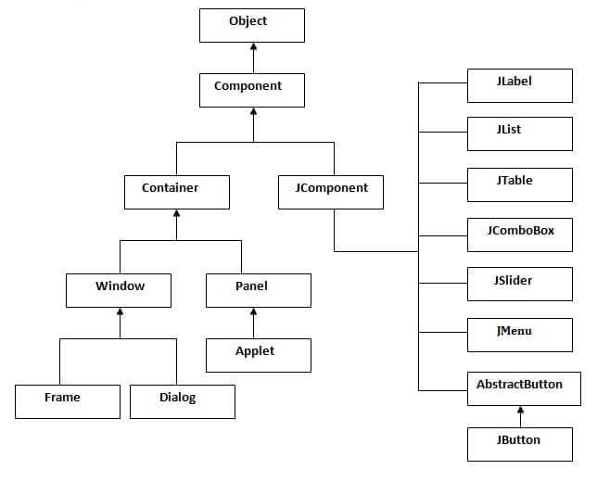

Commonly Used Methods of Component Class
The methods of Component class are widely used in Java swing that are given below.
Method | Description
public void add(Component c) | It add a component on another component.
public void setSize(int width,int height) | It sets size of the component.
public void setLayout(LayoutManager m) | It sets the layout manager for the component.
public void setVisible(boolean b) | It sets the visibility of the component. It is by default false.

Java Swing Examples
There are two ways to create a frame:
- By creating the object of Frame class (association)
- By extending Frame class (inheritance)
We can write the code of swing inside the main(), constructor or any other method.

Java Swing Example
Let's see a simple swing example where we are creating one button and adding it on the JFrame object inside the main() method.
File Name: FirstSwingExample.java

import javax.swing.*;
public class FirstSwingExample {
public static void main(String[] args) {
JFrame f=new JFrame();//creating instance of JFrame

JButton b=new JButton("click");//creating instance of JButton
b.setBounds(130,100,100, 40);//x axis, y axis, width, height

f.add(b);//adding button in JFrame

f.setSize(400,500);//400 width and 500 height
f.setLayout(null);//using no layout managers
f.setVisible(true);//making the frame visible
}
}

Difference between AWT and Swing in Java
AWT and Swing are used to develop window-based applications in Java. Awt is an abstract window toolkit that provides various component classes like Label, Button, TextField, etc., to show window components on the screen. All these classes are part of the Java.awt package.
On the other hand, Swing is the part of JFC (Java Foundation Classes) built on the top of AWT and written entirely in Java. The javax.swing API provides all the component classes like JButton, JTextField, JCheckbox, JMenu, etc.
The components of Swing are platform-independent, i.e., swing doesn't depend on the operating system to show the components. Also, the Swing's components are lightweight. The main differences between AWT and Swing are given in the following table.
Context | AWT | Swing
API Package | The AWT Component classes are provided by the java.awt package. | The Swing component classes are provided by the javax.swing package.
Operating System | The Components used in AWT are mainly dependent on the operating system. | The Components used in Swing are not dependent on the operating system. It is completely scripted in Java.
Weightiness | The AWT is heavyweight since it uses the resources of the operating system. | The Swing is mostly lightweight since it doesn't need any Operating system object for processing. The Swing Components are built on the top of AWT.
Appearance | The Appearance of AWT Components is mainly not configurable. It generally depends on the operating system's look and feels. | The Swing Components are configurable and mainly support pluggable look and feel.
Number of Components | The Java AWT provides a smaller number of components in comparison to Swing. | Java Swing provides a greater number of components than AWT, such as list, scroll panes, tables, color choosers, etc.
Full-Form | Java AWT stands for Abstract Window Toolkit. | Java Swing is mainly referred to as Java Foundation Classes (JFC).
Peers | Java AWT has 21 peers. There is one peer for each control and one peer for the dialogue. Peers are provided by the operating system in the form of widgets themselves. | Java Swing has only one peer in the form of OS's window object, which provides the drawing surface used to draw the Swing's widgets (label, button, entry fields, etc.) developed directly by Java Swing Package.
Functionality and Implementation | Java AWT many features that are completely developed by the developer. It serves as a thin layer of development on the top of the OS. | Swing components provide the higher-level inbuilt functions for the developer that facilitates the coder to write less code.
Memory | Java AWT needs a higher amount of memory for the execution. | Java Swing needs less memory space as compared to Java AWT.
Speed | Java AWT is slower than swing in terms of performance. | Java Swing is faster than the AWT.

Java Swing Hierarchy
Java defines the class hierarchy for all the Swing Components, which is shown in the following image.
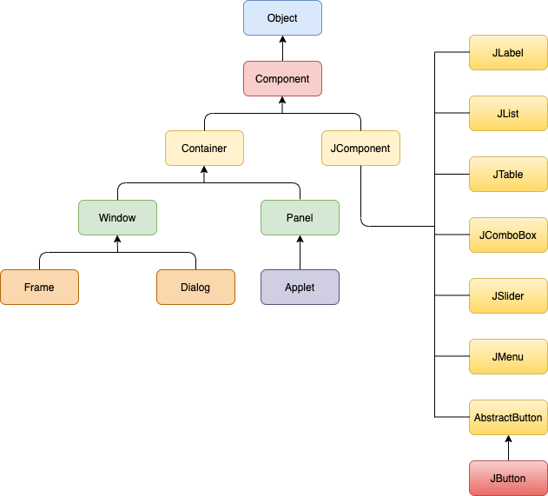

Java Swing Example
In the following example, we have created a User form by using the swing component classes provided by the javax.swing package. Consider the example.

Example

//Java Program to create Swing application in Java
import javax.swing.*;
public class SwingApp {
SwingApp(){
//Creating instance of JFrame class
JFrame f = new JFrame();

//Creating Swing Components
JLabel firstName = new JLabel("First Name");
firstName.setBounds(20, 50, 80, 20);

JLabel lastName = new JLabel("Last Name");
lastName.setBounds(20, 80, 80, 20);

JLabel dob = new JLabel("Date of Birth");
dob.setBounds(20, 110, 80, 20);

JTextField firstNameTF = new JTextField();
firstNameTF.setBounds(120, 50, 100, 20);

JTextField lastNameTF = new JTextField();
lastNameTF.setBounds(120, 80, 100, 20);

JTextField dobTF = new JTextField();
dobTF.setBounds(120, 110, 100, 20);

JButton sbmt = new JButton("Submit");
sbmt.setBounds(20, 160, 100, 30);

JButton reset = new JButton("Reset");
reset.setBounds(120,160,100,30);

//Adding Components on JFrame
f.add(firstName);
f.add(lastName);
f.add(dob);
f.add(firstNameTF);
f.add(lastNameTF);
f.add(dobTF);
f.add(sbmt);
f.add(reset);

//Set size, layout and visibility of the JFrame
f.setSize(300,300);
f.setLayout(null);
f.setVisible(true);
}

//Creating the main method to create object of the class
public static void main(String[] args) {
SwingApp s = new SwingApp();
}
}
Output:
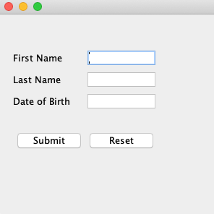

Java AWT Example
To understand the differences between Awt and Swing, we have created the same example in awt as well. Consider the following example.

Example

//Java Program to create AWT application in Java
import java.awt.*;
public class AwtApp extends Frame {
AwtApp(){
//Creating AWT Components
Label firstName = new Label("First Name");
firstName.setBounds(20, 50, 80, 20);

Label lastName = new Label("Last Name");
lastName.setBounds(20, 80, 80, 20);

Label dob = new Label("Date of Birth");
dob.setBounds(20, 110, 80, 20);

TextField firstNameTF = new TextField();
firstNameTF.setBounds(120, 50, 100, 20);

TextField lastNameTF = new TextField();
lastNameTF.setBounds(120, 80, 100, 20);

TextField dobTF = new TextField();
dobTF.setBounds(120, 110, 100, 20);

Button sbmt = new Button("Submit");
sbmt.setBounds(20, 160, 100, 30);

Button reset = new Button("Reset");
reset.setBounds(120,160,100,30);

//Adding components on Frame
add(firstName);
add(lastName);
add(dob);
add(firstNameTF);
add(lastNameTF);
add(dobTF);
add(sbmt);
add(reset);

//Set size, layout and visibility of the frame
setSize(300,300);
setLayout(null);
setVisible(true);
}
//Creating main method to create the object of the class
public static void main(String[] args) {
AwtApp awt = new AwtApp();
}
}
Output:
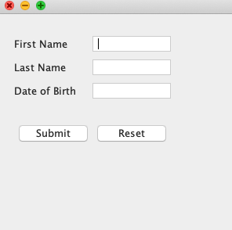

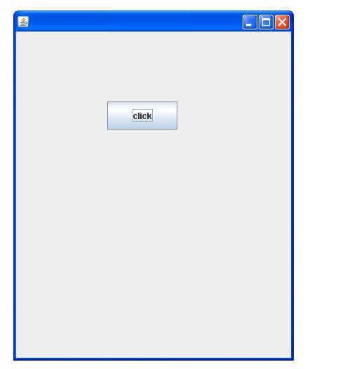

Example of Swing by Association Inside Constructor
We can also write all the codes of creating JFrame, JButton and method call inside the java constructor.
File Name: Demo.java

import javax.swing.*;
public class Demo {
JFrame f;
Simple(){
f=new JFrame();//creating instance of JFrame
JButton b=new JButton("click");//creating instance of JButton
b.setBounds(130,100,100, 40);
f.add(b);//adding button in JFrame
f.setSize(400,500);//400 width and 500 height
f.setLayout(null);//using no layout managers
f.setVisible(true);//making the frame visible
}
public static void main(String[] args) {
new Demo();
}
}
The setBounds(int xaxis, int yaxis, int width, int height)is used in the above example that sets the position of the button.
Output:
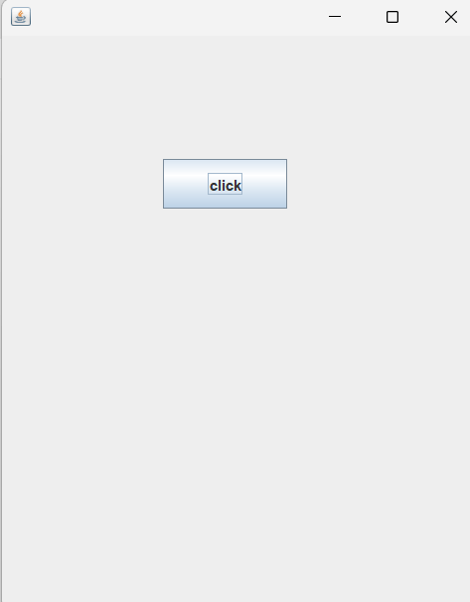

Example of Swing by Inheritance
We can also inherit the JFrame class, so there is no need to create the instance of JFrame class explicitly.
File Name: DemoSwing.java

import javax.swing.*;
public class DemoSwing extends JFrame{//inheriting JFrame
JFrame f;
Simple2(){
JButton b=new JButton("click");//create button
b.setBounds(130,100,100, 40);
add(b);//adding button on frame
setSize(400,500);
setLayout(null);
setVisible(true);
}
public static void main(String[] args) {
new Simple2();
}}
Output:

Java JButton
The JButton class is used to create a labeled button that has platform independent implementation. The application result in some action when the button is pushed. It inherits AbstractButton class.
A key element of graphical user interfaces (GUIs) in Java that is used to create interactive buttons is the JButton class. Users can click these labelled buttons to initiate particular operations within the application. Because JButton offers a platform-independent implementation, it can be used in a variety of settings and operating systems. It is descended from the AbstractButton class, which offers shared functionality for all button kinds in the Swing GUI framework and Java's Abstract Window Toolkit (AWT). Developers can improve the usability and interactivity of their Java programmes by adding sensible user interface components to their JButton objects through configuration.

JButton class declaration
Let's see the declaration for javax.swing.JButton class.

public class JButton extends AbstractButton implements Accessible

Commonly used Constructors:
Constructor | Description
JButton() | It creates a button with no text and icon.
JButton(String s) | It creates a button with the specified text.
JButton(Icon i) | It creates a button with the specified icon object.
JButton(String s, Icon i) | Creates a button with both specified text and icon.

Commonly used Methods of AbstractButton class:
Methods | Description
void setText(String s) | It is used to set specified text on button
String getText() | It is used to return the text of the button.
void setEnabled(boolean b) | It is used to enable or disable the button.
void setIcon(Icon b) | It is used to set the specified Icon on the button.
Icon getIcon() | It is used to get the Icon of the button.
void setMnemonic(int a) | It is used to set the mnemonic on the button.
void addActionListener(ActionListener a) | It is used to add the action listener to this object.
void setSelected(boolean selected) | Sets the selected state of the button, typically used for toggle buttons.
boolean isSelected() | Returns true if the button is selected, false otherwise.
void setToolTipText(String text) | Sets the tooltip text that appears when the mouse hovers over the button.
String getToolTipText() | Returns the tooltip text of the button.
void setBorder(Border border) | Sets the border of the button.
Border getBorder() | Returns the border of the button.
void setForeground(Color fg) | Sets the foreground color of the button's text.
Color getForeground() | Returns the foreground color of the button's text.
void setBackground(Color bg) | Sets the background color of the button.
Color getBackground() | Returns the background color of the button.
void setFont(Font font) | Sets the font of the button's text.
Font getFont() | Returns the font of the button's text.
void setFocusPainted(boolean painted) | Sets whether the button should paint the focus indication around its border when focused.
boolean isFocusPainted() | Returns true if the button paints the focus indication around its border when focused, false otherwise.
void setHorizontalAlignment(int alignment) | Sets the horizontal alignment of the button's text.
int getHorizontalAlignment() | Returns the horizontal alignment of the button's text.
void setVerticalAlignment(int alignment) | Sets the vertical alignment of the button's text.
int getVerticalAlignment() | Returns the vertical alignment of the button's text.

Java JButton Example
Filename: ButtonExample.java

import javax.swing.*;
public class ButtonExample {
public static void main(String[] args) {
JFrame f=new JFrame("Button Example");
JButton b=new JButton("Click Here");
b.setBounds(50,100,95,30);
f.add(b);
f.setSize(400,400);
f.setLayout(null);
f.setVisible(true);
}
}
Output:
Explanation
This Java code shows how to use a JButton to create a simple Swing application. When it runs, a JFrame window named "Button Example" with a JButton labelled "Click Here" appears. The button is 95 pixels wide and 30 pixels height, and it is located inside the window at coordinates (50, 100). Absolute coordinates are used to manually position components when the JFrame's layout manager is configured to null layout. The user is then able to see the JFrame, which is now 400 pixels wide and 400 pixels height. This straightforward configuration demonstrates the key elements and layout control of a Swing-based graphical user interface.

Java JButton Example with ActionListener
Filename: ButtonExample.java

import java.awt.event.*;
import javax.swing.*;
public class ButtonExample {
public static void main(String[] args) {
JFrame f=new JFrame("Button Example");
final JTextField tf=new JTextField();
tf.setBounds(50,50, 150,20);
JButton b=new JButton("Click Here");
b.setBounds(50,100,95,30);
b.addActionListener(new ActionListener(){
public void actionPerformed(ActionEvent e){
tf.setText("Welcome to Javatpoint.");
}
});
f.add(b);f.add(tf);
f.setSize(400,400);
f.setLayout(null);
f.setVisible(true);
}
}
Output:
Explanation
This extended Java code enhances the previous example by incorporating functionality to the JButton. Upon clicking the JButton labeled "Click Here," the JTextField below it is updated with the text "Welcome to Javatpoint." This functionality is achieved by adding an ActionListener to the button. When the button is clicked, the actionPerformed method of the ActionListener interface is invoked, and the setText method is called on the JTextField to update its content. The JFrame is displayed with both the button and the text field, utilizing absolute positioning through null layout. This example demonstrates how to handle events in Swing applications, enabling interactive user experiences.

Example of Displaying Image On the Button
Filename: ButtonExample.java

import javax.swing.*;
public class ButtonExample{
ButtonExample(){
JFrame f=new JFrame("Button Example");
JButton b=new JButton(new ImageIcon("D:\\icon.png"));
b.setBounds(100,100,100, 40);
f.add(b);
f.setSize(300,400);
f.setLayout(null);
f.setVisible(true);
f.setDefaultCloseOperation(JFrame.EXIT_ON_CLOSE);
}
public static void main(String[] args) {
new ButtonExample();
}
}
Output:
Explanation
The ButtonExample class, defined in this Java code, generates a Swing application with a JFrame holding a JButton that displays an ImageIcon. An image icon is loaded from the provided file location when the JButton is first initialised. The JFrame is configured with the title "Button Example" and 300 x 400 pixel width and height. The JFrame's default close operation is set to terminate the programme when closed, and the layout manager is set to null, allowing manual component positioning. When this programme runs, it displays a window with a button that has the designated picture icon on it. This allows for basic Java environment graphical interaction.

